**Lab 09b - Implement Azure Container Instances**

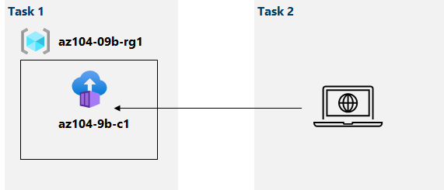

**Task 1: Deploy a Docker image by using the Azure Container Instance**  
  
Search for container instances and create one:  
in the Basics and networking part input the provided settings   
click review and create the container instance

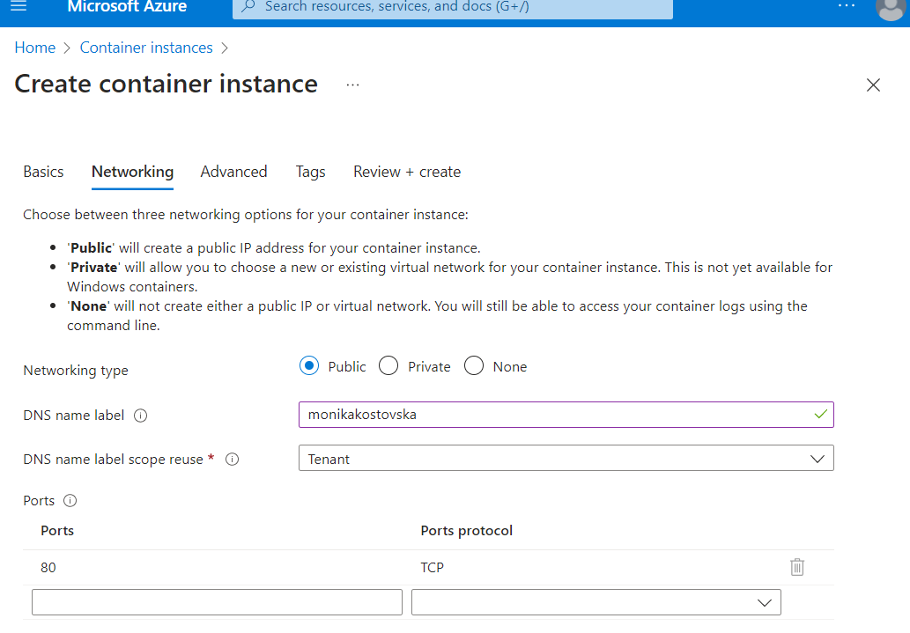

#### Task 2: Review the functionality of the Azure Container Instance

**Go to resource** link and o**verview** the container instance,  
 verify that **status** is reported as **running**

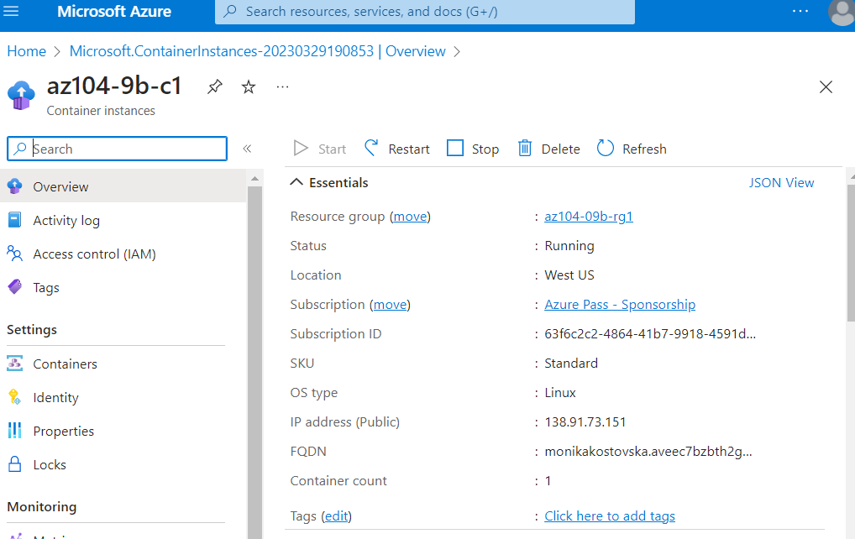

We collect the container instance FQDN and open the URL link in new tab  
The result will look like this:

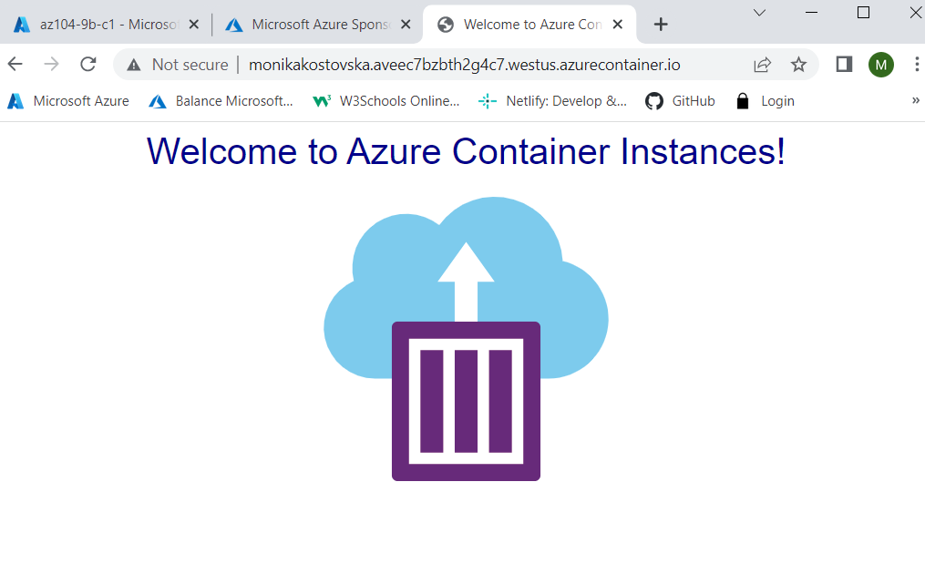

And if we open containers and logs we can verify that the log entries representing the HTTP GET request are generated by displaying the application in the browser.

